Summary of requirements and any final adjustments
Main functional requirements.
- The system queries the flagged transactions to show which wallet behaviors are associated with confirmed fraud (statistics page).
- The system classifies a pending transaction as suspicious or clean.
- The system shows the three most similar past transactions along with the one classified as fraud.
- The system takes as an input one flagged transaction.

Design Overview
Streamlit was used to build the user interface of the application. We used the navigation buttons between pages, input fields for transaction data input, a button to initiate the prediction, and interface elements for displaying DataFrames and text outputs.
SQL queries (through pandasql) were used for filtering the initial dataset during data preparation and for producing statistical results on the Statistics page.
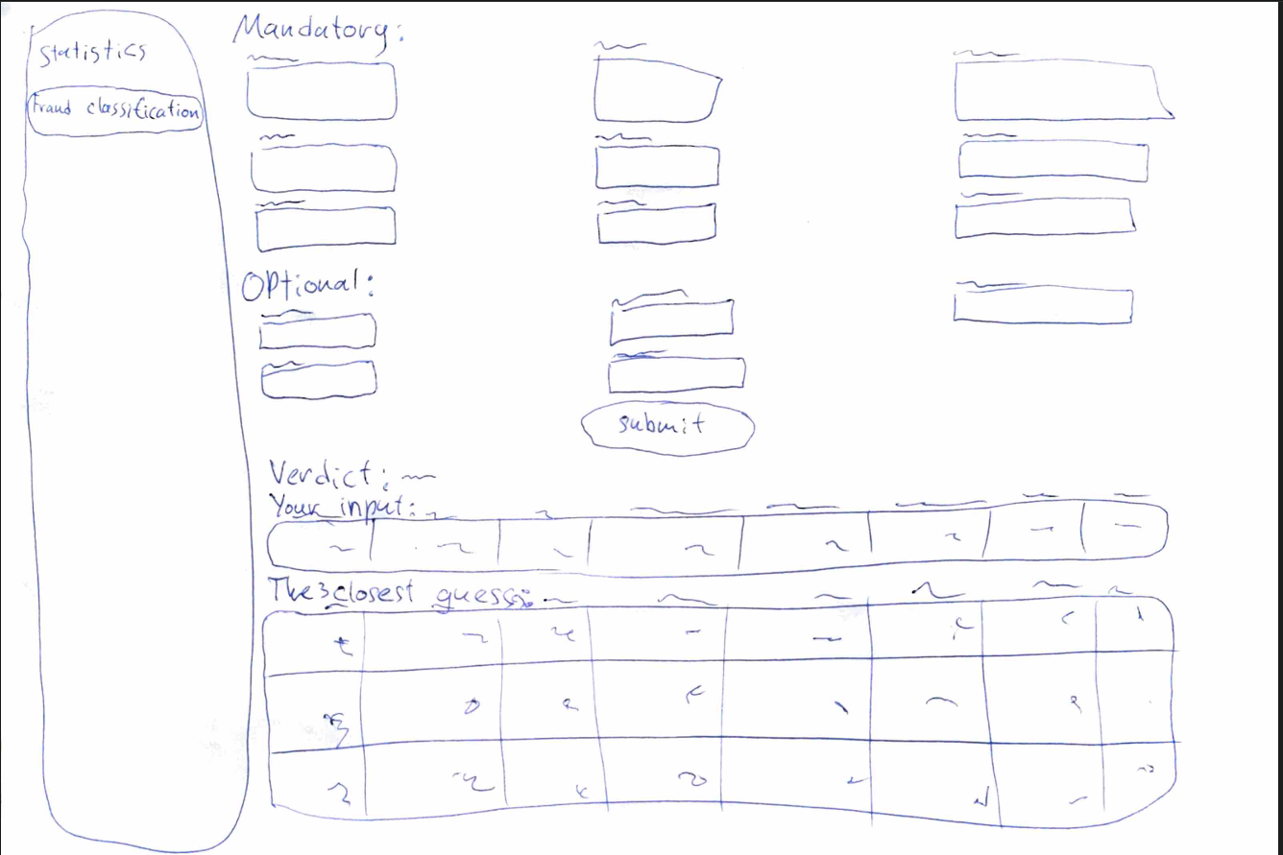

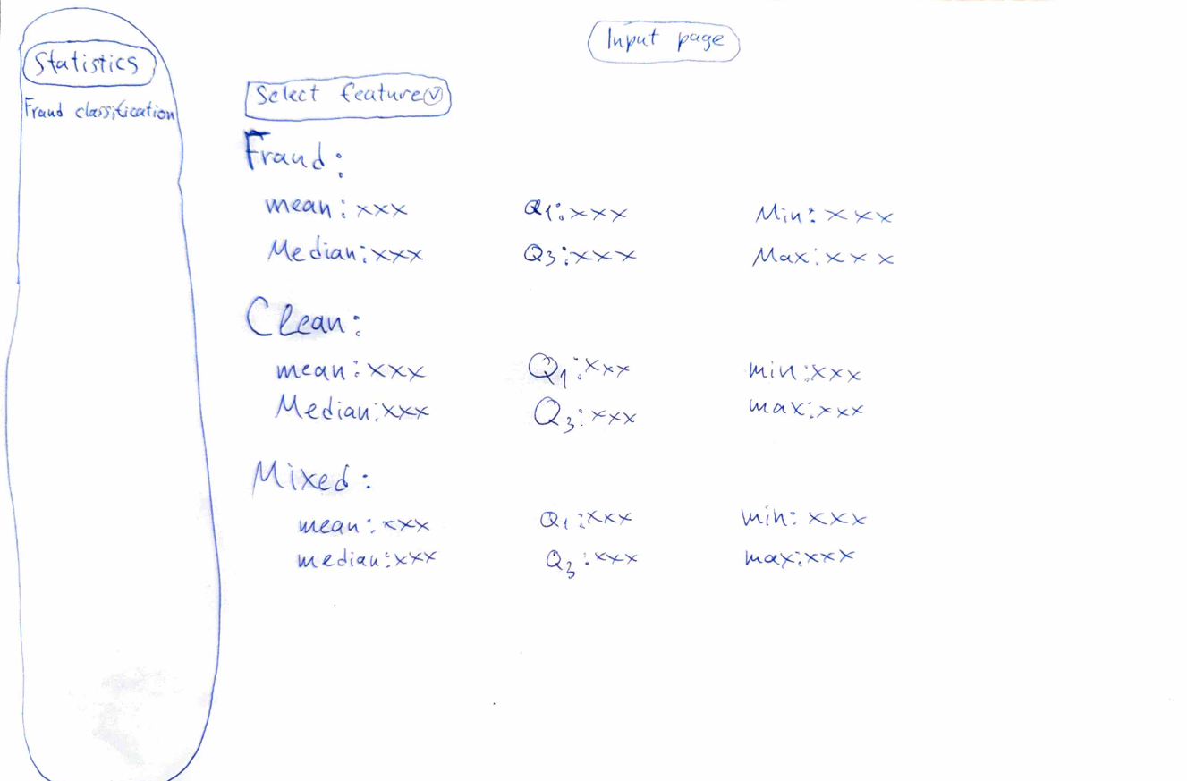
Architecture:
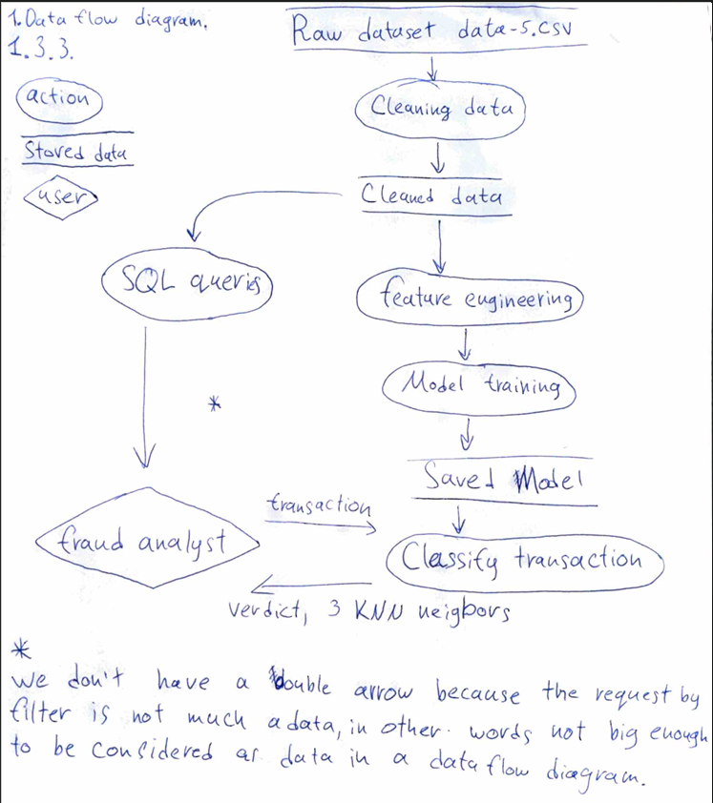

Data Cleaning
After querying the dataset we discovered that there were no missing values and inconsistencies. But we discovered that we have a lot of outliers, therefore we kept them because they were almost 50 percent of our dataset. Consequently, we didn’t do any data cleaning in order to train the model.

Model evaluation results and interpretation
In order to get the best performance dataset we went through several iterations, some examples are:
- Based on the executed queries we assumed the following dataset will have a better performance than the raw dataset excluding the following columns :
columns = [
"tx_hour",
"input_count",
"output_count",
"tx_count_24h",
"unique_counterparties_24h",
"max_graph_hop",
"gas_price_pctile",
"is_weekend" ]
But contrary to our assumption the result was worse:
The first set's MAE: 0.35, RMSE: 0.5916079783099616
The second set's MAE: 0.3625, RMSE: 0.6020797289396148
The difference between MAE: -0.012500000000000011, and between RMSE: -0.01047175062965322
- After executing backward elimination on the same dataset, we discovered that we had to remove new_address_fraction and balance_change

We had those results:
Mae: 0.3, Rmse: 0.5477225575051661

Implementation
Using streamlit we made the front end, where the user needs to input all the mandatory fields. Every field in the mandatory and the optional section start as empty, and the optional fields as the name suggests, are not needed to be filled for the model to predict if the transaction is fraud or clean. The user gives the inputs and then we are feeding those inputs into the model in order for the model to predict if the transaction is fraud or not and then we display the result to the user and the three most similar transactions.
Furthermore, the system queries the flagged transactions to show which wallet behaviors are associated with confirmed fraud (statistics page).

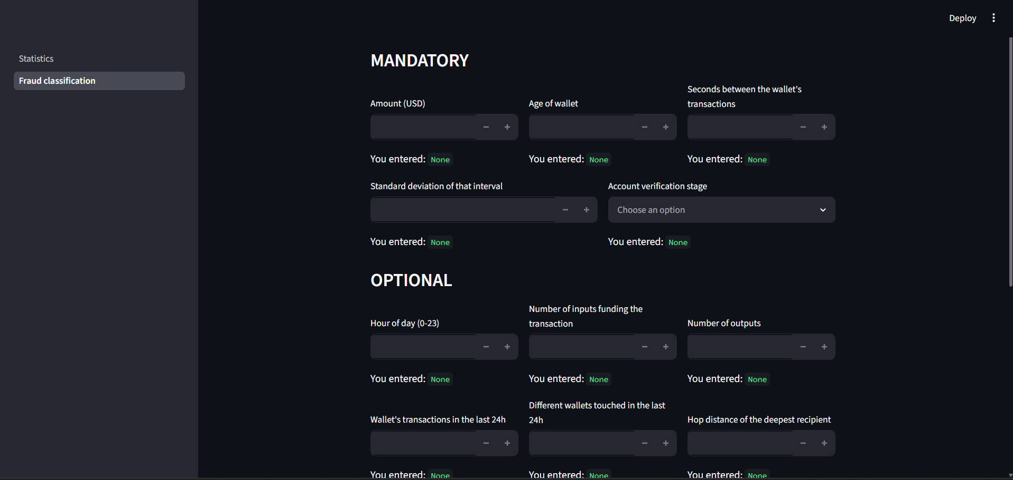

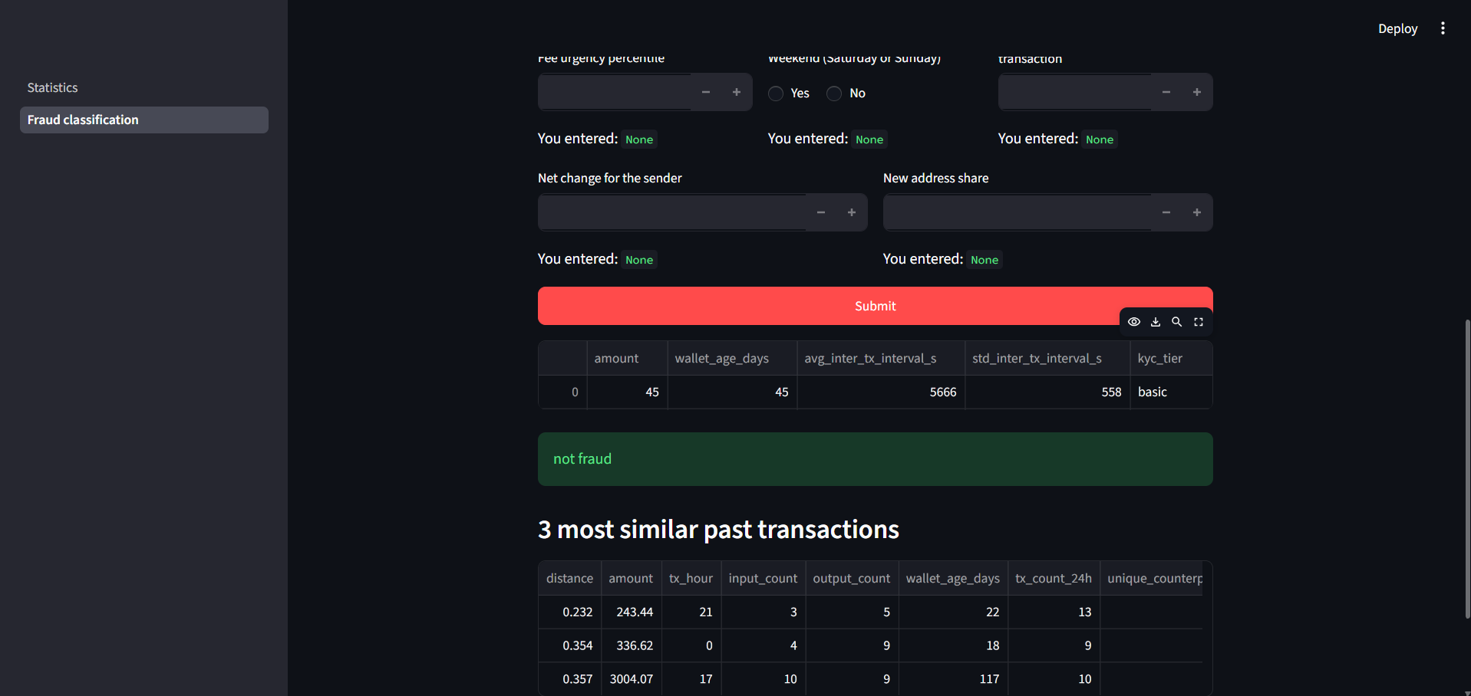

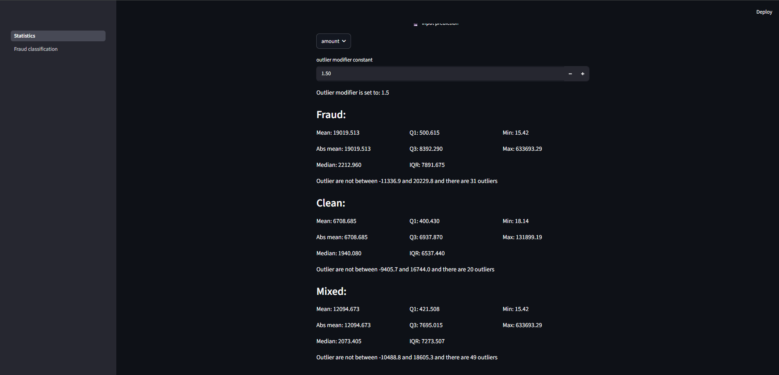

Reflection on teamwork, process and outcomes
For everyone in this dream team, teamwork itself was something new to experience. We divided into smaller teams to work more efficiently, and this really helped us.

One team worked on data cleaning and machine learning, while the other team focused on the design, structure, and functionality of the application. Towards the end of the app building, the teams combined their work and corrected several mistakes. For example, team two found that missing numerical values should be replaced using the mean calculated from the training dataset, rather than from the full raw dataset. Everyone did a great job and contributed to the final result.

After the project was completed, we had a big “Conclusion Evening”, where we discussed what we had learned throughout the project. Looking back, the whole journey we went through together turned out to be both very interesting and extremely useful.

If we had had more time, we would have improved the structure and readability of our code, tested more combinations during data cleaning and machine learning, and added more functionality to the application. We would also have spent more time learning how to use Git effectively, so that working together on the same project would be easier and more organized.

